

**CAR RENTAL**

**Software Requirement Specification**

– Hanoi, February 2023 –

***Thành viên trong nhóm***

***Lê Trung Đức - SE05390***

***Nguyễn Trí Trường Sơn - HE151167***

***Nguyễn Hữu Minh Đức - HE151166***

**Table of Contents**

1 Overall Description **3**

1.1 Introduction 3

1.2.1 Screen Functions 4

1.2.2 Non-Screen Functions 5

1.2.3 Common Requirements 5

1.3 Screen Description 6

1.3.1 Screen Flow 6

1.3.2 Screen Details 6

1.3.3 User Authorization 7

2 System Features **9**

1.1 Sign In 9

1.1.1 Screen Design 9

1.1.2 Use case Specification 10

1.2 Sign Up 11

1.2.1 Screen Design 11

1.2.2 Use case Specification 12

1.3 Forgot Password 13

1.3.1 Screen Design 13

1.3.2 Use case Specification 14

1.4 Car List 14

1.4.1 Screen Design 14

1.4.2 Use case Specification 15

1.5 Car details 15

1.5.1 Screen Design 15

1.5.2 Use case Specification 16

1.6 PaymentPayment 17

1.6.1 Screen Design 17

1.6.2 Use case Specification 18

2.1 Admin 19

1.1 Dashboard 19

1.1.1 Screen Design 19

1.1.2 Use case Specification 20

1.2 List car 20

1.1.1 Screen Design 20

1.1.2 Use case Specification 21

1.2 Car detail 22

1.1.1 Screen Design 22

1.1.2 Use case Specification 23

# 1 Overall Description

## 1.1 Introduction

Transport facility is a matter of headache for those people who do not have any personal transport in Ha Noi city or any other major city. On occasions like Wedding, Vacation, house shifting, and tour outside your city and on many other situations they feel the necessity of a vehicle to sort out the problems. So if it is possible to design or develop a android application for availing transport whenever and wherever possible, then it will be beneficial for both renter and transport provider. Nowadays, by some touch only, we can get whatever you want at home. We already know about the online shopping, e-banking etc. Similarly, The Car Rental System is the online facility to book cars online within few action only. Some people can not afford to have a car, for those people this system becomes very helpful. This system includes various cars, as per the customer order and comfort, it place the order and deliver the car as per the location within the area. For travelling a long distance, booking can be done via internet service only

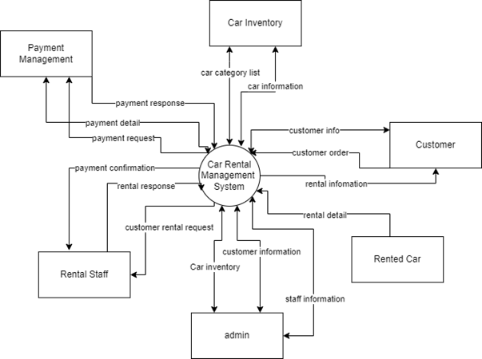

Figure 1-1: Car Rental Management System overview

As described in Figure 1-1, the system will have the following component:

* Admin
* Rental Staff
* Rented Car
* Customer
* Car Inventory
* Payment management

**1.2 Feature Descriptions**

### 1.2.1 Screen Functions

| **#** | **Feature** | **System Function** | **Description** |
| --- | --- | --- | --- |
| 1 | Common | User Login | Enter email & password to login |
| 2 | Common | User Register | Register to the system. |
| 3 | Public | Home Page | Show system information. |
| 4 | Public | Car list | Show the list of car (include car' id, name, price):  The user can filter the post by date, status; also the user can search the car by name  The list car can be sortable by name, price , status |
| 5 | Public | Car details | Show detailed car information (thumbnail, features, description, utility, rental document). |
| 6 | Admin | Dashboard | Show statistics of new orders (success, cancelled, submitted), revenues (total, by product categories), customers (rent car). |
| 7 | Admin | List car (Admin) | Show the list of cars (include car' id, thumbnail, features, description, utility, rental document, and status information). |
| 8 | Admin | Car detail (Admin) | Show detailed car information. Edit and save car detail. |
| 9 | Customer | Payment | A rental car payment screen displays the cost of the rental. |

### 1.2.2 Non-Screen Functions

| **#** | **Feature** | **System Function** | **Description** |
| --- | --- | --- | --- |
| 1 | Common | Sign out | Users sign out of the system |
| 2 | Common | User Authorization | Authorise user into the system functions based on his/her role |

### 1.2.3 Common Requirements

***Functional Requirements:***

User authentication: The software should allow users to create and manage their own account, including login and password protection.

Vehicle search and reservation: The software should allow users to search for available rental cars by location, date, and vehicle type, and reserve a car for a specified time period.

Payment processing: The software should allow users to make secure payments for their rental car reservation, including the ability to process credit card and debit card payments.

***Non-Functional Requirements:***

Performance: The software should load and process data quickly, with response times of no more than 2 seconds for user requests.

Usability: The software should be user-friendly and easy to navigate, with clear and concise instructions for users.

Scalability: The software should be able to handle increasing amounts of data and user traffic without sacrificing performance.

***User Requirements:***

Multi-language support: The software should be available in multiple languages to support a global user base.

***Technical Requirements:***

Data storage: The software should use a secure and scalable data storage solution, such as Amazon S3 or Google Cloud Storage.

## 1.3 Screen Description

### 1.3.1 Screen Flow

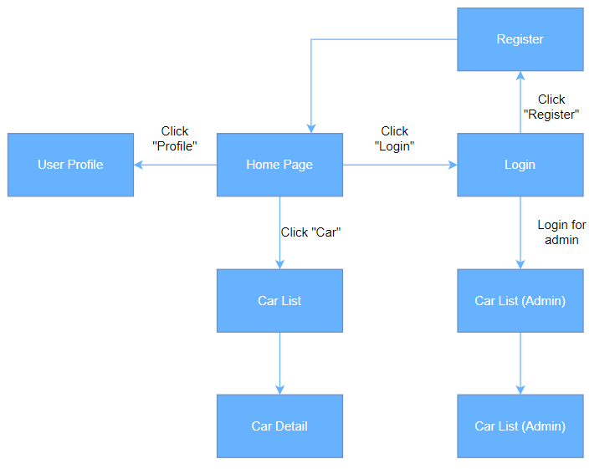

### 

### 

### 1.3.2 Screen Details

| **#** | **Feature** | **Screen** | **Description** |
| --- | --- | --- | --- |
| 1 | Common | User Login | This is a screen which allows the user to enter  email & password to login |
| 2 | Common | User Register | This is a screen which allows the user to register to the system by inputting following information: full name, email, mobile, address |
| 3 | Common | User profile | Show registered users (include users' id, full name, gender, email, mobile, role, status). |
| 4 | Public | Home page | Show hot car, featured car, category of car. |
| 5 | Public | Car List | Show the paginated list of car (include car' id, name, price):  The user can filter the post by date, status; also the user can search the car by name  The list car can be sortable by name, price , status |
| 6 | Public | Car detail | Show detailed car information (thumbnail, features, description, utility, rental document), from that allow the user to input new post information, view or edit existing post information |
| 7 | Admin | Dashboard | Show statistics of new orders (success, cancelled, submitted), revenues (total, by product categories), customers (rent car) |
| 8 | Admin | Car List | Show the list of cars (include car' id, thumbnail, features, description, utility, rental document, and status information):  -The user can filter the car by category, status or search by name  - Sortable by name, list price, featured, or status  - From each car, the user can choose to hide, show, view, edit it  - The page also have the button/link that allows the user to add new car |
| 9 | Admin | Car Detail | Show detailed car information (thumbnail, features, description, utility, rental document status), from that allow the user to input, view or edit them |
| 10 | Customer | Payment | A rental car payment screen displays the cost of the rental. It allows the selection of a payment method and requests billing information. It has a button to confirm the reservation. |

### 

### 

### 

### 1.3.3 User Authorization

| **Screen** | **Admin** | **Guest** | **Customer** |
| --- | --- | --- | --- |
| User Login |  | X |  |
| User Register |  | X |  |
| User profile | X | X | X |
| Home page | X | X | X |
| Car List | X | X | X |
| Car Detail | X | X | X |
| Dashboard | X |  |  |
| Car List (Admin) | X |  |  |
| Car Detail (Admin) | X |  |  |
| Payment |  |  | X |

In which:

* Admin: the organisation leader/manager, acts as the system administrator.
* Guest: unregistered users
* Customer: they are registered users who are actual customers or potential customers

# 2 System Features

### 1.1 Login

#### 1.1.1 Screen Design

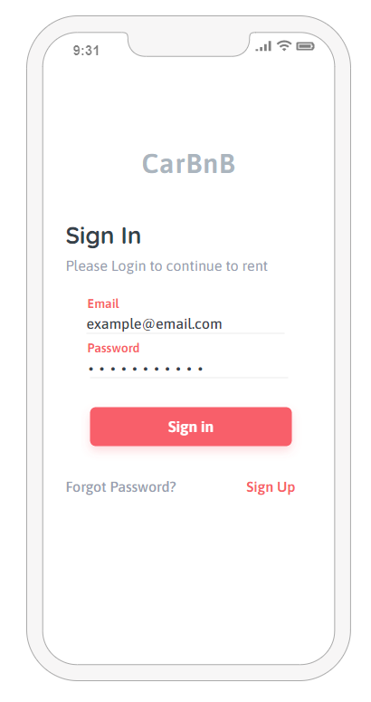

**Figure 3-1**: Screen Design of Login

**Table 1-1: Screen Definition**

| **#** | **Field Name** | **Type** | **Mandatory** | **Max Length** | **Description** |
| --- | --- | --- | --- | --- | --- |
| 1 | User Name | Text | Yes | 20 |  |
| 2 | Password | Text | Yes | 20 | Display "*" instead of clear character |
| 3 | Login | Button |  |  | Go to home page |
| 4 | Forgot Password | Button |  |  |  |
| 5 | Sign Up | Button |  |  |  |

#### 1.1.2 Use case Specification

Actor: Car Rental customer

Goal: To sign in to application

Pre-conditions:

Customer already had an account link to the app.

Flow of Events:

User open app , if user not logged in than so sign in screen.

The System show up sign in screen with username and password as user input and optional for User that forgot their password

After signed in the main DashBoard show up

### 1.2 Sign Up

#### 1.2.1 Screen Design

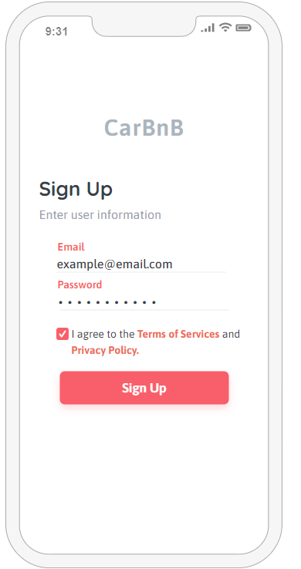

**Figure 3-2**: Screen Design of Sign Up

**Table 1-2: Screen Definition**

| **#** | **Field Name** | **Type** | **Mandatory** | **Max Length** | **Description** |
| --- | --- | --- | --- | --- | --- |
| 1 | User Name | Text | Yes | 20 |  |
| 2 | Password | Text | Yes | 20 | Display "*" instead of clear character |
| 3 | Login | Button |  |  | Go to home page |
| 4 | Sign Up | Button |  |  |  |

#### 1.2.2 Use case Specification

Actor: Car Rental customer

Goal: To sign up to application

Pre-conditions:

Customer doesn’t have an existing account for the system.

Flow of Events:

User clicked on Sign up button on sign in screen.

The system transition to sign up screen.

User input email address and password , check on checkbox to sign up to the system

After sign up system transition back to sign in screen

### 1.3 Forgot Password

#### 1.3.1 Screen Design

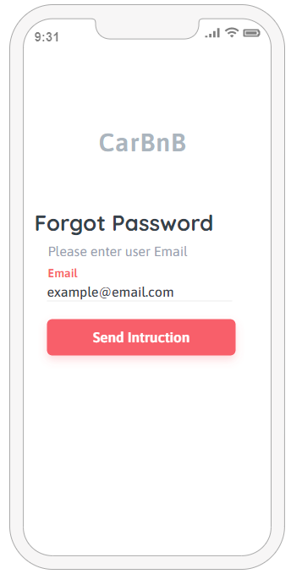

**Figure 3-3**: Screen Design of Forgot Password

**Table 1-3: Screen Definition**

| **#** | **Field Name** | **Type** | **Mandatory** | **Max Length** | **Description** |
| --- | --- | --- | --- | --- | --- |
| 1 | Email | Text | Yes | none |  |
| 4 | Send instruction | Button |  |  |  |

#### 

#### 1.3.2 Use case Specification

Actor: Car Rental customer

Goal: Send request forgot password

Pre-conditions:

Customer had an existing account for the system.

Flow of Events:

User clicked on Forgot password button in sign in screen,

System transition to forgot password screen .

User enter Email using to register pre existed account.

User click on send instruction button and system transition back to sign in screen.

### 1.4 Car List

#### 1.4.1 Screen Design

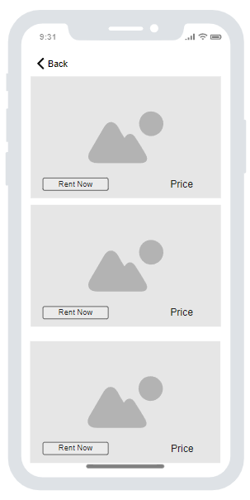

**Table 1-4: Screen Definition**

| **#** | **Field Name** | **Type** | **Mandatory** | **Max Length** | **Description** |
| --- | --- | --- | --- | --- | --- |
| 1 | Back | Button |  |  | Go to home page |
| 2 | Rent now | Button |  |  | Go to payment page |
| 3 | Image | Link |  |  | Go to car details |

#### 

#### 1.4.2 Use case Specification

| **Use Case ID** | | **UC01** | **Use Case Name** | | **List car** | |
| --- | --- | --- | --- | --- | --- | --- |
| **Author** | | **DucNHM** | **Version** | **1.0** | **Date** | **08/02/2023** |
| **Actor** | | Customer | | | | |
| **Description** | | To view a list of available rental cars and their details | | | | |
| **Precondition** | | PRE-01: Car rental agent is logged into the car rental system. | | | | |
| **Trigger** | | TRG-01: Car rental agent clicks on the "List Rent Cars" button. | | | | |
| **Post-Condition** | | POS-01: Has access to a list of available rental cars and their details | | | | |
| **Main flows** | | | | | | |
| ***Step*** | ***Actor*** | ***Action*** | | | | |
| *1* | Customer | Login | | | | |
| *2* | Customer | Click on the "List Rent Cars" button. | | | | |

### 

#### 

#### 

### 1.5 Car details

#### 1.5.1 Screen Design

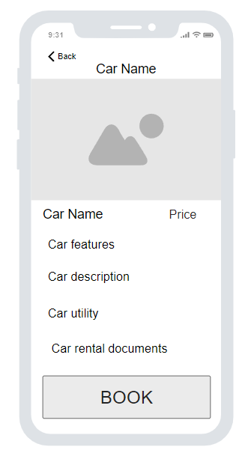

##### 

**Table 1-5: Screen Definition**

| **#** | **Field Name** | **Type** | **Mandatory** | **Max Length** | **Description** |
| --- | --- | --- | --- | --- | --- |
| 1 | Back | Button |  |  | Go to car list page |
| 2 | Book | Button |  |  | Go to payment page |

##### 

#### 1.5.2 Use case Specification

| **Use Case ID** | | **UC01** | **Use Case Name** | | **Car details** | |
| --- | --- | --- | --- | --- | --- | --- |
| **Author** | | **DucNHM** | **Version** | **1.0** | **Date** | **08/02/2023** |
| **Actor** | | Customer | | | | |
| **Description** | | To view detailed information about a specific rental car | | | | |
| **Precondition** | | PRE-01: Car rental agent is logged into the car rental system.  PRE-02: The rental car of interest is listed in the system. | | | | |
| **Trigger** | | TRG-01: Car rental agent clicks on the image of car in list car | | | | |
| **Post-Condition** | | POS-01: Car rental agent has access to detailed information about the selected rental car, which they can use to make informed decisions about renting the car to customers. | | | | |
| **Main flows** | | | | | | |
| ***Step*** | ***Actor*** | ***Action*** | | | | |
| *1* | Customer | Login | | | | |
| *2* | Customer | Click on the "List Rent Cars" button. | | | | |
| *3* | Customer | Click on the image of car in list car | | | | |

### 1.6 PaymentPayment

#### 1.6.1 Screen Design

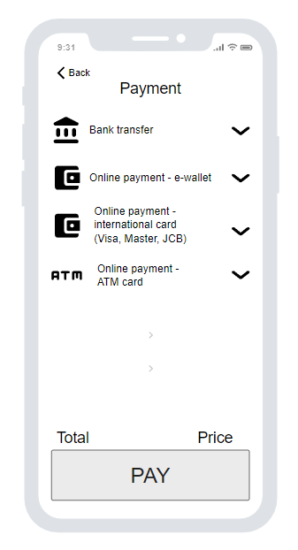

**Table 1-6: Screen Definition**

| **#** | **Field Name** | **Type** | **Mandatory** | **Max Length** | **Description** |
| --- | --- | --- | --- | --- | --- |
| 1 | Back | Button |  |  | Go to car details or car list page |
| 2 | Pay | Button |  |  | Pay car and go to home page |

#### 1.6.2 Use case Specification

| **Use Case ID** | | **UC01** | **Use Case Name** | | **Payment** | |
| --- | --- | --- | --- | --- | --- | --- |
| **Author** | | **DucNHM** | **Version** | **1.0** | **Date** | **08/02/2023** |
| **Actor** | | Customer | | | | |
| **Description** | | To make a payment for a rented car. | | | | |
| **Precondition** | | PRE-01: Customer has selected a rental car. | | | | |
| **Trigger** | | TRG-01: Customer clicks on the "BOOK" button. | | | | |
| **Post-Condition** | | POS-01: Customer's payment has been processed and the rental car is reserved for the specified dates. | | | | |
| **Main flows** | | | | | | |
| ***Step*** | ***Actor*** | ***Action*** | | | | |
| *1* | Customer | Login | | | | |
| *2* | Customer | Click on the "rent now" button. | | | | |
| *3* | Customer | Click on the "Pay" button. | | | | |

## 

## 

## 

## 

## 2.1 Admin

### 1.1 Dashboard

#### 1.1.1 Screen Design

* *Function trigger: This function is triggered when the user login with the admin role.*
* *Function description: Show statistics revenues (total, by cars), customers.*
* *Screen layout: mockup prototype of the screen, sample below is for Admin Dashboard screen*

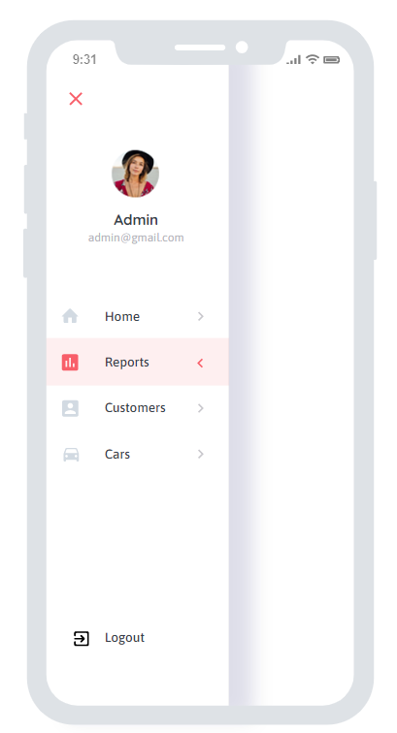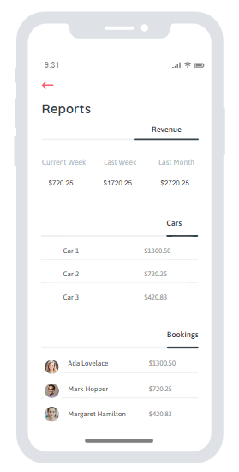

**Table 1-1: Screen Definition**

| **#** | **Field Name** | **Type** | **Mandatory** | **Max Length** | **Description** |
| --- | --- | --- | --- | --- | --- |
| 1 | Home | Button |  |  | Go to home page |
| 2 | Reports | Button |  |  | Go to reports page |
| 3 | Customers | Button |  |  | Go to manage customers |
| 4 | Cars | Button |  |  | Go to manage cars |

#### 1.1.2 Use case Specification

| **Use Case ID** | | **UC01** | **Use Case Name** | | **Dashboard** | |
| --- | --- | --- | --- | --- | --- | --- |
| **Author** | | **SonNTT** | **Version** | **1.0** | **Date** | **08/02/2023** |
| **Actor** | | Admin | | | | |
| **Description** | | The function allows a user to be able to see reports. Manage customers and cars in the system.. | | | | |
| **Precondition** | | PRE-01: Login for admin | | | | |
| **Trigger** | | TRG-01: | | | | |
| **Post-Condition** | | POS-01: User with admin role | | | | |
| **Main flows** | | | | | | |
| ***Step*** | ***Actor*** | ***Action*** | | | | |
| *1* | Admin | Login with admin role | | | | |

### 1.2 List car

#### 1.1.1 Screen Design

* *Function trigger: This function is triggered when the user login with the admin role and clicks “Cars” on the dashboard.*
* *Function description: Show List of cars and description.*
* *Screen layout: mockup prototype of the screen, sample below is for List car screen*

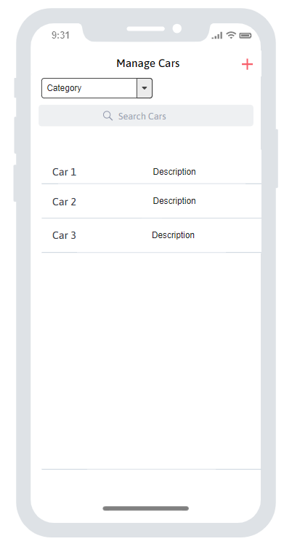

**Table 1-1: Screen Definition**

| **#** | **Field Name** | **Type** | **Mandatory** | **Max Length** | **Description** |
| --- | --- | --- | --- | --- | --- |
| 1 | + | Button |  |  | Add new car |
| 2 | Category | Dropdown |  |  | Fill cars by category |
| 3 | Search | Text |  |  | Search car by keyword |
| 4 | Specific Car | Link |  |  | Go to Car detail |

#### 1.1.2 Use case Specification

| **Use Case ID** | | **UC01** | **Use Case Name** | | **Add new car** | |
| --- | --- | --- | --- | --- | --- | --- |
| **Author** | | **SonNTT** | **Version** | **1.0** | **Date** | **08/02/2023** |
| **Actor** | | Admin | | | | |
| **Description** | | The function allows a user to be able to add new car. | | | | |
| **Precondition** | | PRE-01: Login for admin | | | | |
| **Trigger** | | TRG-01: Click “Cars” on dashboard | | | | |
| **Post-Condition** | | POS-01: User with admin role | | | | |
| **Main flows** | | | | | | |
| ***Step*** | ***Actor*** | ***Action*** | | | | |
| *1* | Admin | Login with admin role | | | | |
| *2* | Admin | Click “Cars” on the dashboard. | | | | |
| *3* | Admin | Click “+” | | | | |

### 1.2 Car detail

#### 1.1.1 Screen Design

* *Function trigger: This function is triggered when the user login with the admin role and clicks Specific Car on list car.*
* *Function description: Show List of cars and description.*
* *Screen layout: mockup prototype of the screen, sample below is for Car detail screen*

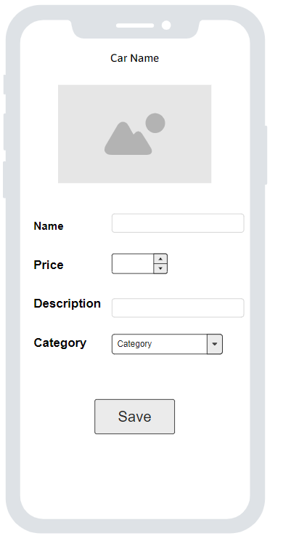

**Table 1-1: Screen Definition**

| **#** | **Field Name** | **Type** | **Mandatory** | **Max Length** | **Description** |
| --- | --- | --- | --- | --- | --- |
| 1 | Image | Button |  |  | Choose image |
| 2 | Name | Text |  | 100 | Edit car name |
| 3 | Price | Number |  |  | Edit car price |
| 4 | Category | Dropdown |  |  | Edit car category |
| 5 | Save | Button |  |  | Save specific car |

#### 

#### 1.1.2 Use case Specification

| **Use Case ID** | | **UC01** | **Use Case Name** | | **Edit car** | |
| --- | --- | --- | --- | --- | --- | --- |
| **Author** | | **SonNTT** | **Version** | **1.0** | **Date** | **08/02/2023** |
| **Actor** | | Admin | | | | |
| **Description** | | The function allows a user to be able to edit car. | | | | |
| **Precondition** | | PRE-01: Login for admin | | | | |
| **Trigger** | | TRG-01: Click specific car on list car | | | | |
| **Post-Condition** | | POS-01: User with admin role | | | | |
| **Main flows** | | | | | | |
| ***Step*** | ***Actor*** | ***Action*** | | | | |
| *1* | Admin | Login with admin role | | | | |
| *2* | Admin | Click the specific car on list car. | | | | |
| *3* | Admin | Update information of car | | | | |
| *3* | Admin | Click “Save” | | | | |